# COMPUTER NETWORKS LAB 3

## **STEPS TAKEN**:

**STEP 1:**

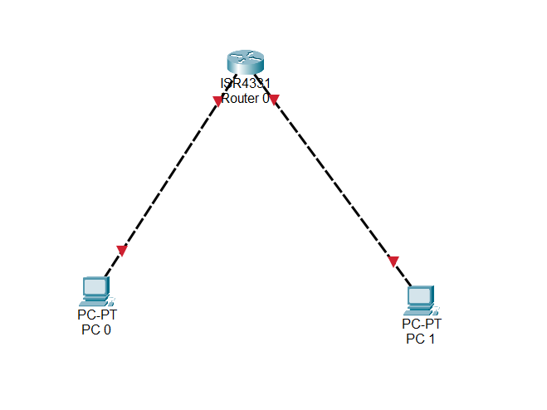

Dragged a ISR4331 Switch and 2 PCs on to the canvas and used Copper Cross-over cable to connect each PC’s port FastEthernet0/0 to the router’s GigabitEthernet0/0/0 and 0/0/1 respectively.

**STEP 2:**

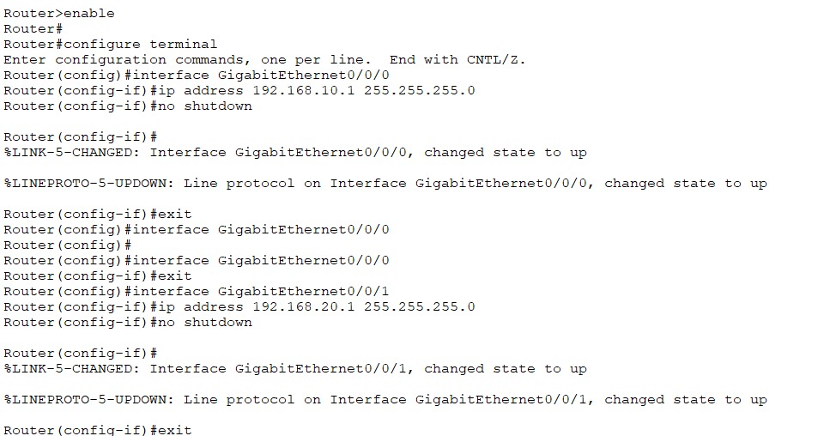

After typing the above commands on the Router, the connection is successful indicated by the green triangles on the cables below.

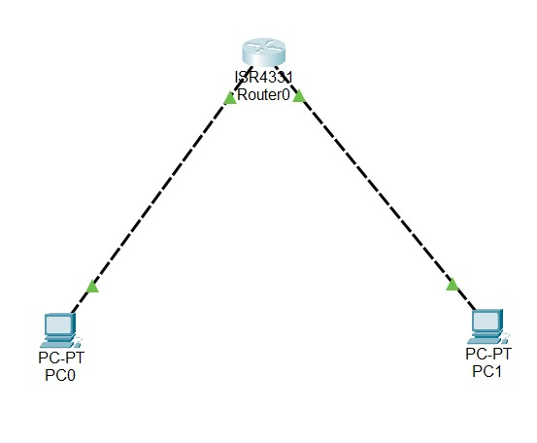

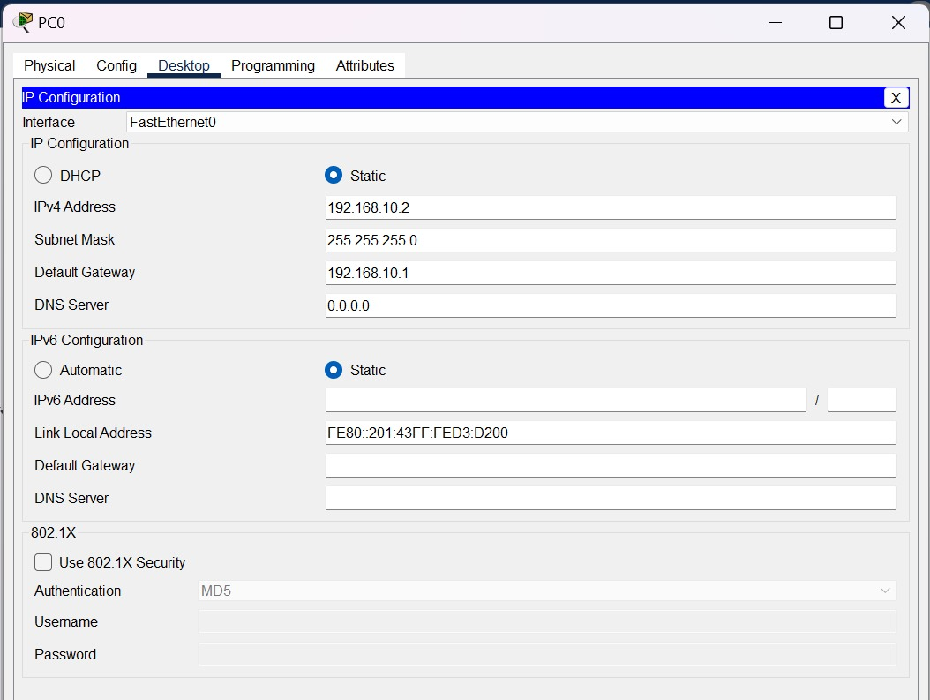

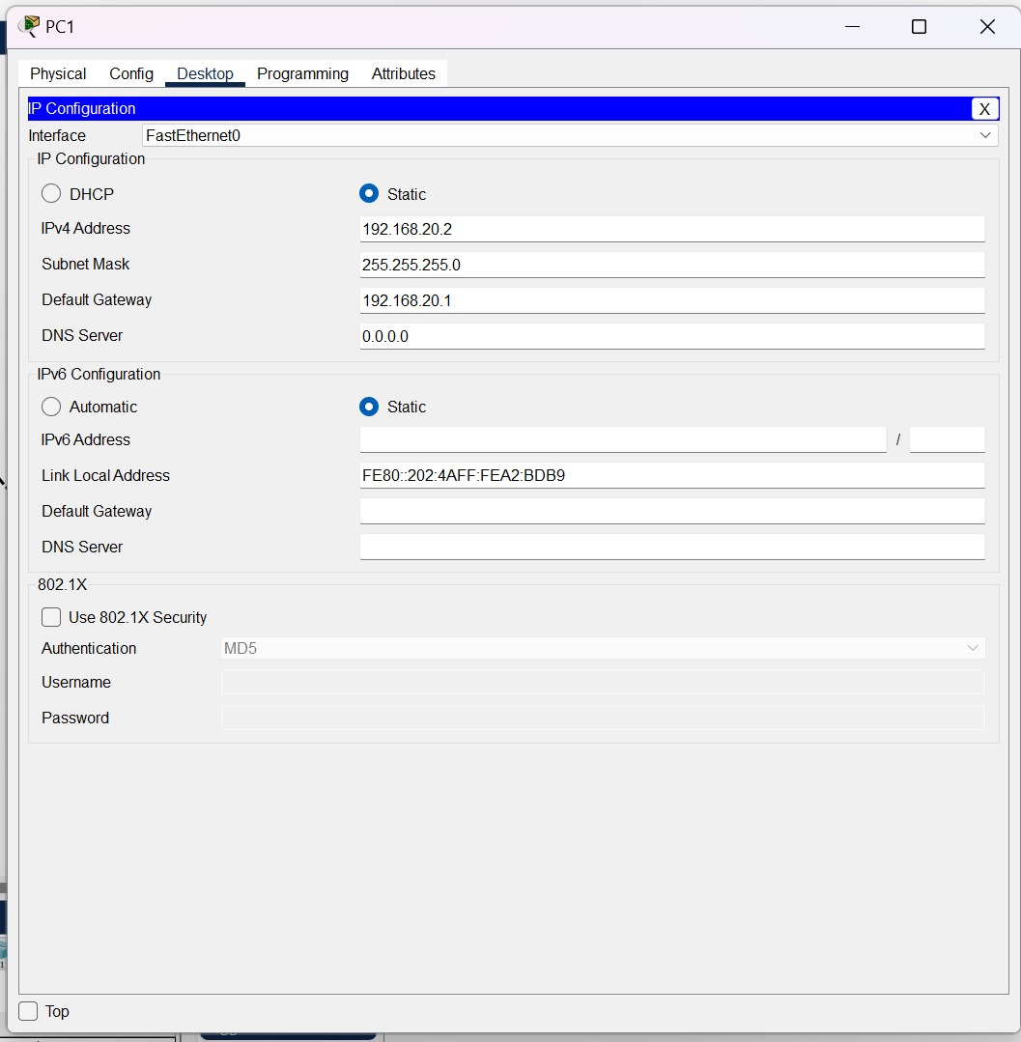

Pinging from PC1 to PC0:

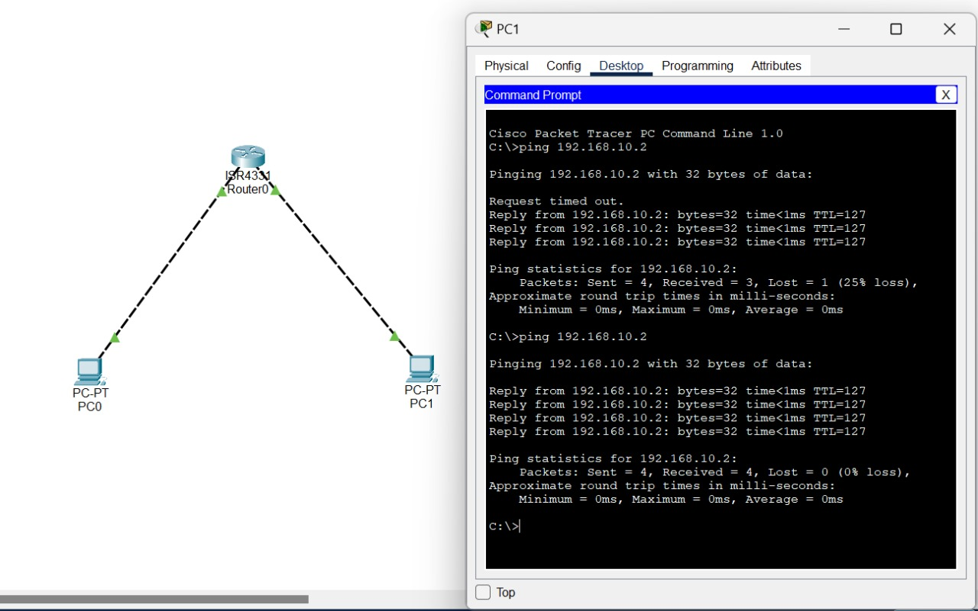

**STEP 3:**

BASIC ROUTER SETUP

Setting passwords/authentication to the router

